**Dockerfile**

Docker ps -a

Docker build .

: build custom image

docker stop container-name

docker run -p 80:3000 image_name

: We create containers from image (blueprint)

docker -it run node

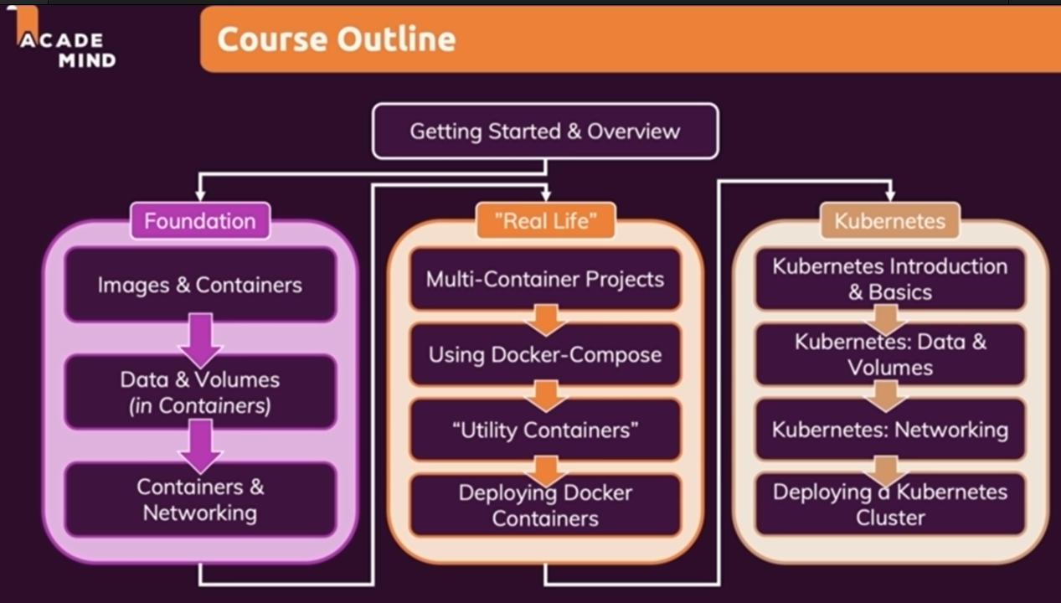

**Data and Volumes in containers**: persistent data on containers

**Deploying docker containers**: on **AWS**

**Docker-compose** is for managing multi container projects

RUN vs CMD in Dockerfile: CMD should be the last line in file.(and it will be executed whenever we start/restart a container)

Dockerfile’s instructions order is important, because Docker architecture is **layer based.**

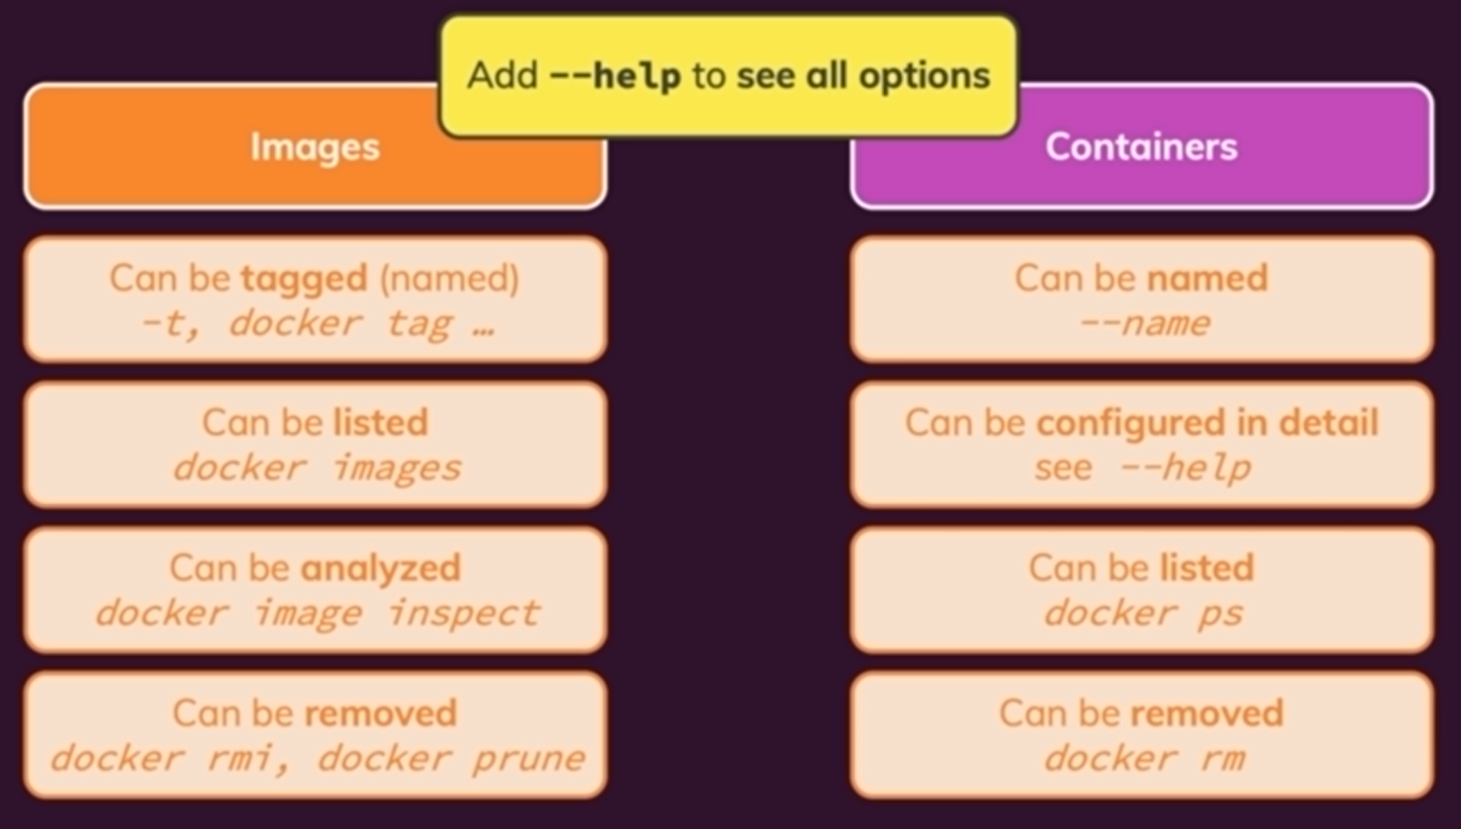

docker restart vs docker start

docker start runs in bg (for fg: docker start -a image_name) but docker run runs in attached mode(foreground). For detach mode use -d and for attach again: docker container attach <CONTAINER_NAME>

docker logs CONAINER_NAME -f

docker -it run

docker container or images prune : remove all stopped container. For removing tagged images you need to add -a

docker images : list all images

docker rmi image_name : you can not remove images that are used by containers (whether it is stopped or not)

docker run -p … -d –rm image_name : remove container as when it is stopped.

Different commands in Dockerfile made different layers plus base image file.

Docker image size is big, because it contains all the code and working directory. But container itself is just a small layer upon that image

docker image inspect image_id

docker cp /dummy/. container_name:/app/test/ : allows to move/get files to/from running container. Useful to get log files or update config files

**Naming** images🡺(when building) -t NodeB:latest or containers🡺 --name myCIn

Image tags consist of 2 parts: **name**(or repo of your image)**:tag** (check images on docker-hub)

**Sharing images**:

* + **Dockerhub**: create a repository ( because the image itself is a repo at end)
    - docker push HOST:NAME
      * Before we able to push: docker login or docker logout
      * The image name should be **username/name**
      * Rename currently available image: docker tag old_name:old_tag(optional) username/new_name:new_tag(optional)
        + The old image will be still available.
    - docker pull: will fetch the latest image. **Fetch image before running it to make sure to get latest version**
  + There are other private registry stuff other than Dockerhub for images

Temp Data that user enters in app, when it is running. It is container because **images are read-only**

**Permanent Data**: stored data on remove ( the stop makes no issue) of container 🡺 **Volumes**: folder on local machine, mapped to container.(**changes in either will reflected in another folder**)

docker volume ls : bind mounts are not shown because they are not managed by Docker itself

Types of volumes

* **Anonymous**: name of them are assigned by Docker itself and **exists until the container has not been stopped** and the corresponding files on the local will also be deleted. **They often can be used for /tmp folder of apps.**
* **Named volume**: this is the solution
  + No need to volume instruction in Dockerfile
  + Add -v volume_name:/app/feedback when we you want to run or make the container for the first time.

**Bind Mounts**: With that we are able to reflects changes in the local file to the running container without building a new image manually and run the container based on that again. That is because we manage the folder on our local machine that container saves to and read from it (unlike volume).

* You still need the Named Volume command
* -v “local_machine_absolute_path_that_those_files_should_be_copied_to_container:/app”
* Docker should have permission to access that path (Check Docker Desktop)

Using Bind Mount will probably cause an error. **Because our local mapped path’s content will not be overwritten by corresponding container (Docker will not do that**). But container’s corresponding mapped folder will be overwritten by specified local path’s contents 🡺 **solution**: you can use anonymous volumes: add -v :/app/node_modules when running container ( you can also use the VOLUME instruction in Dockerfile, but this one is preferred because you don’t have to rebuild the image again). **This method works because Docker always checks all bindings and try to imply all volumes/mounts folders without causing a crash [with the priority of longer path(most specific path)’s binding]**

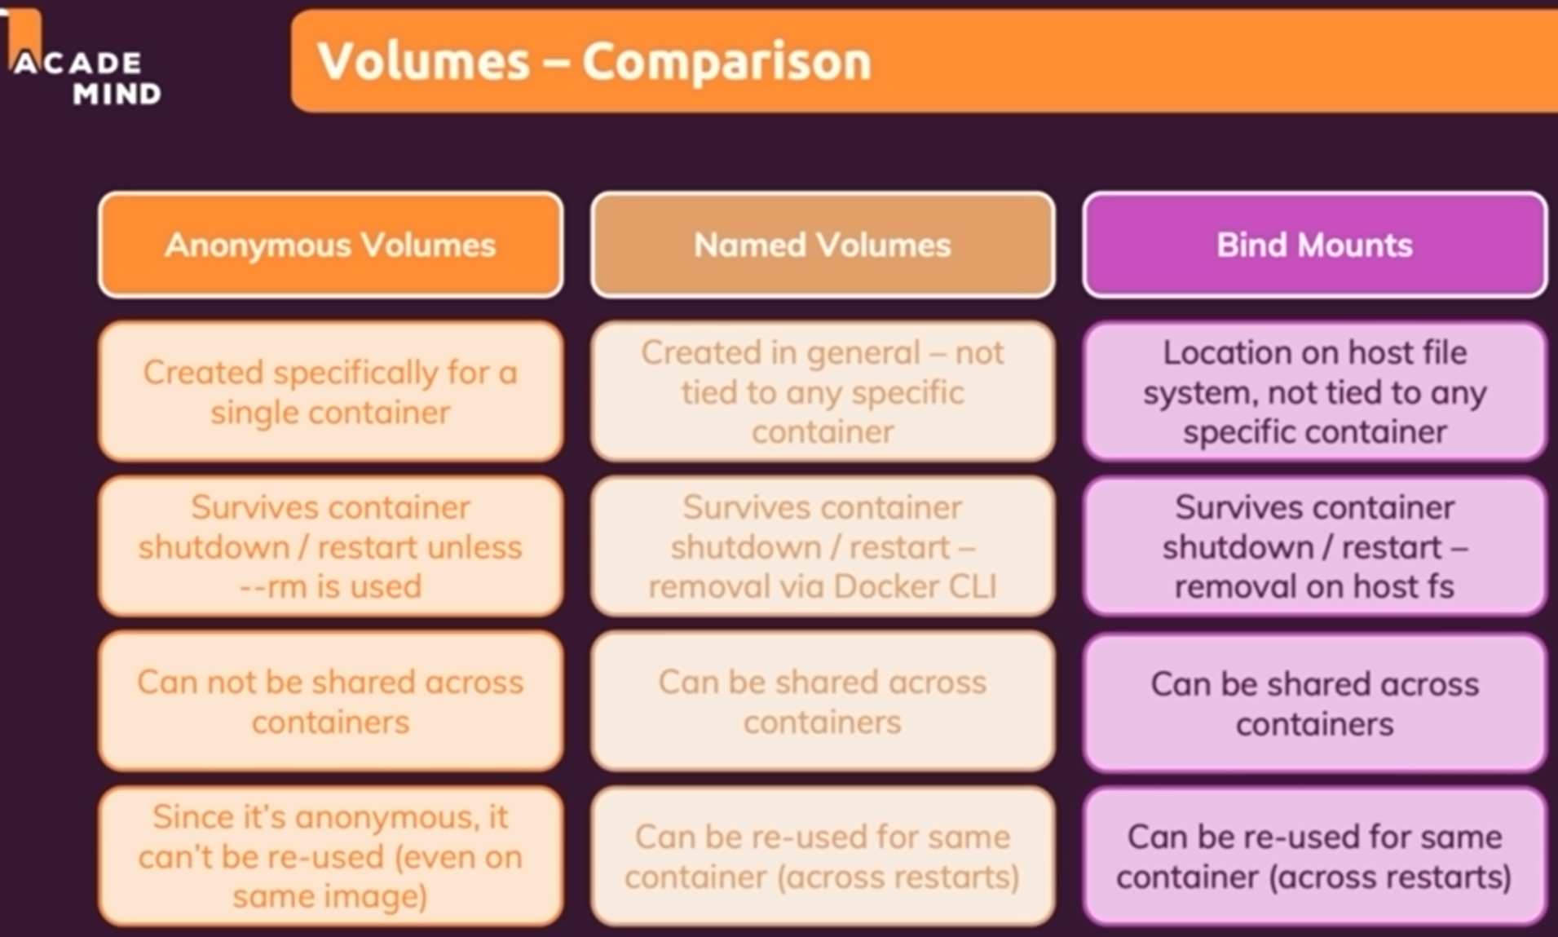

**Read-only volumes**: by default volumes are read-write. Means that container can write in and read from that path. We can add :ro at the end of -v option to made that volume as Read-only for container

docker volume create volume_name: create volume by manual and use(not so usefull)

docker volume inspect volume_name

docker volume rm volume_name

docker volume prune : remove all unused volumes

**.dockerignore** : which files should not be copied by CP instruction. Examples:

Dockerfile

.git

Node-modules

**Arguments and Environment**

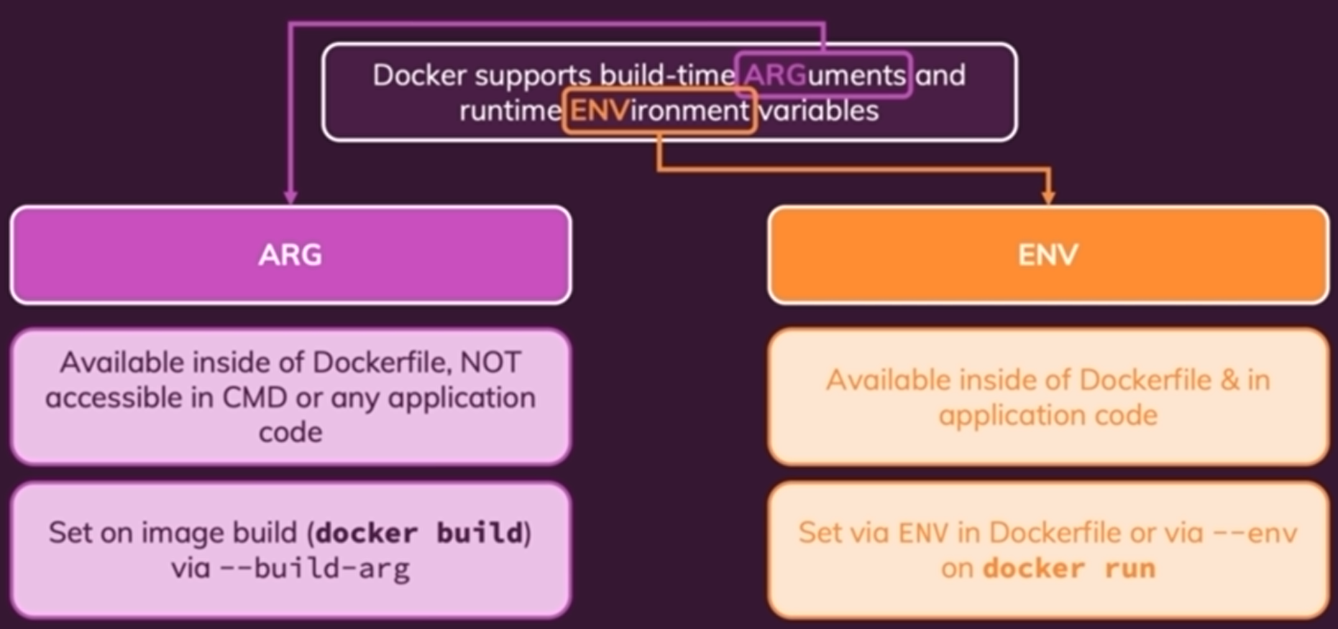

**Environment Variables**:

ENV PORT=default_value

usage

* Dockerfile: $PORT
* Nodejs: process.env.PORT
* In CMD we can set them when running container: --env PORT=8000 or -e . or you can also create a file **.env** and set all **key=value** and then –env-file local_path/.env

**Arguments**:

ARG DEFAULT_PORT =80

**Container Network**:

* to another Container: use **container’s IP**
* to local host: replace localhost to host.docker.internal
* to world: no need to any change

We can add all containers in a same network using –network my_network option, and Docker will isolate them and do all the IP resolving stuff. But before that, you should create network: docker network create network_name. And after that you can replace IP with container name no need to provide -p option(publishing port).

Docker Networks actually support different kinds of "Drivers" which influence the behavior of the Network. The default driver is the "bridge" driver :

* host: For standalone containers, isolation between container and host system is removed (i.e. they share localhost as a network).
* overlay: Multiple Docker daemons (i.e. Docker running on different machines) are able to connect with each other. Only works in "Swarm" mode which is a dated / almost deprecated way of connecting multiple containers.
* macvlan: You can set a custom MAC address to a container - this address can then be used for communication with that container.
* none: All networking is disabled.
* Third-party plugins: You can install third-party plugins which then may add all kinds of behaviors and functionalities

*docker network create --driver bridge my-net*

**Multi Container Application**:

For JS Applications, you should consider that the code is not running in the container, but in the browser actually.

We done here all the thing for **development** setup, but how can we use docker container for **production** and deploying it to the world (this container setup is not so suitable for that)? Another problem is that also when we use Docker for production setup, it is so hard to remember those long docker run commands.( It is ok when we are in development setup)

**DockerCompose**: Automating multi-container support🡺 **one config file with single orchestration command for setup, start,… multi containers. It works along with Dockerfile, images, containers**. It is suited for managing multiple containers on a single same host.

First you need to write **docker-compose.yaml**:

* **Services(Containers):** Everything you do in regular docker commands for containers. e.g.: published ports, volumes, ….

By default when you stop your services(containers), they will be removed. So no need to –rm option

In most cases, you also no need to specify networks, because compose will do and setup a best environment that suits for us, and will add to same networks all that containers specified in **docker-compose**.

For **bindmounts** no need to absolute path just use **relative path** to **docker-compose**.

Start services: docker-compose up: build all images and start services. To start in detached mode: -d

docker-compose down: delete networks and containers. For deleting volumes: -v (not so good)

For interactive container, use these options)its even override -d option when run-up docker-compose)

stdin_open: true

tty: true

docker-compose build : force to build custom images

**Utility Containers**: We most use **Application Containers**, that contains our code based on an environment. There are other containers named **utility containers**, that are just an environment and we execute/appends custom commands ( docker run mycontainer init)

docker exec container_name npm init : execute commands further Dockerfile instructions

docker run -it container_name npm init : replace default command when we start a container. For Example for Node image, the default command is node which will prompt an interactive terminal.

What are utility container use cases? We can execute commands on container and bind mount the output to the local host, without need to install required packages on our local host.

**Restricting to specific commands**: (in **Dockerfile**) use ENTRYPOINT instead of CMD. And after that, if you give a command when running a utility container, it will append that to ENTRYPOINT (by default that command will replace CMD command). E.g.: ENTRYPOINT[“node”]. For using this with **docker-compose**, you have two choices:

* docker-compose exec init : it will execute init command on running docker-compose services
* docker-compose run --rm container_name init : running a specific service from docker-compose with the given command. Add –build to force to build service image again.

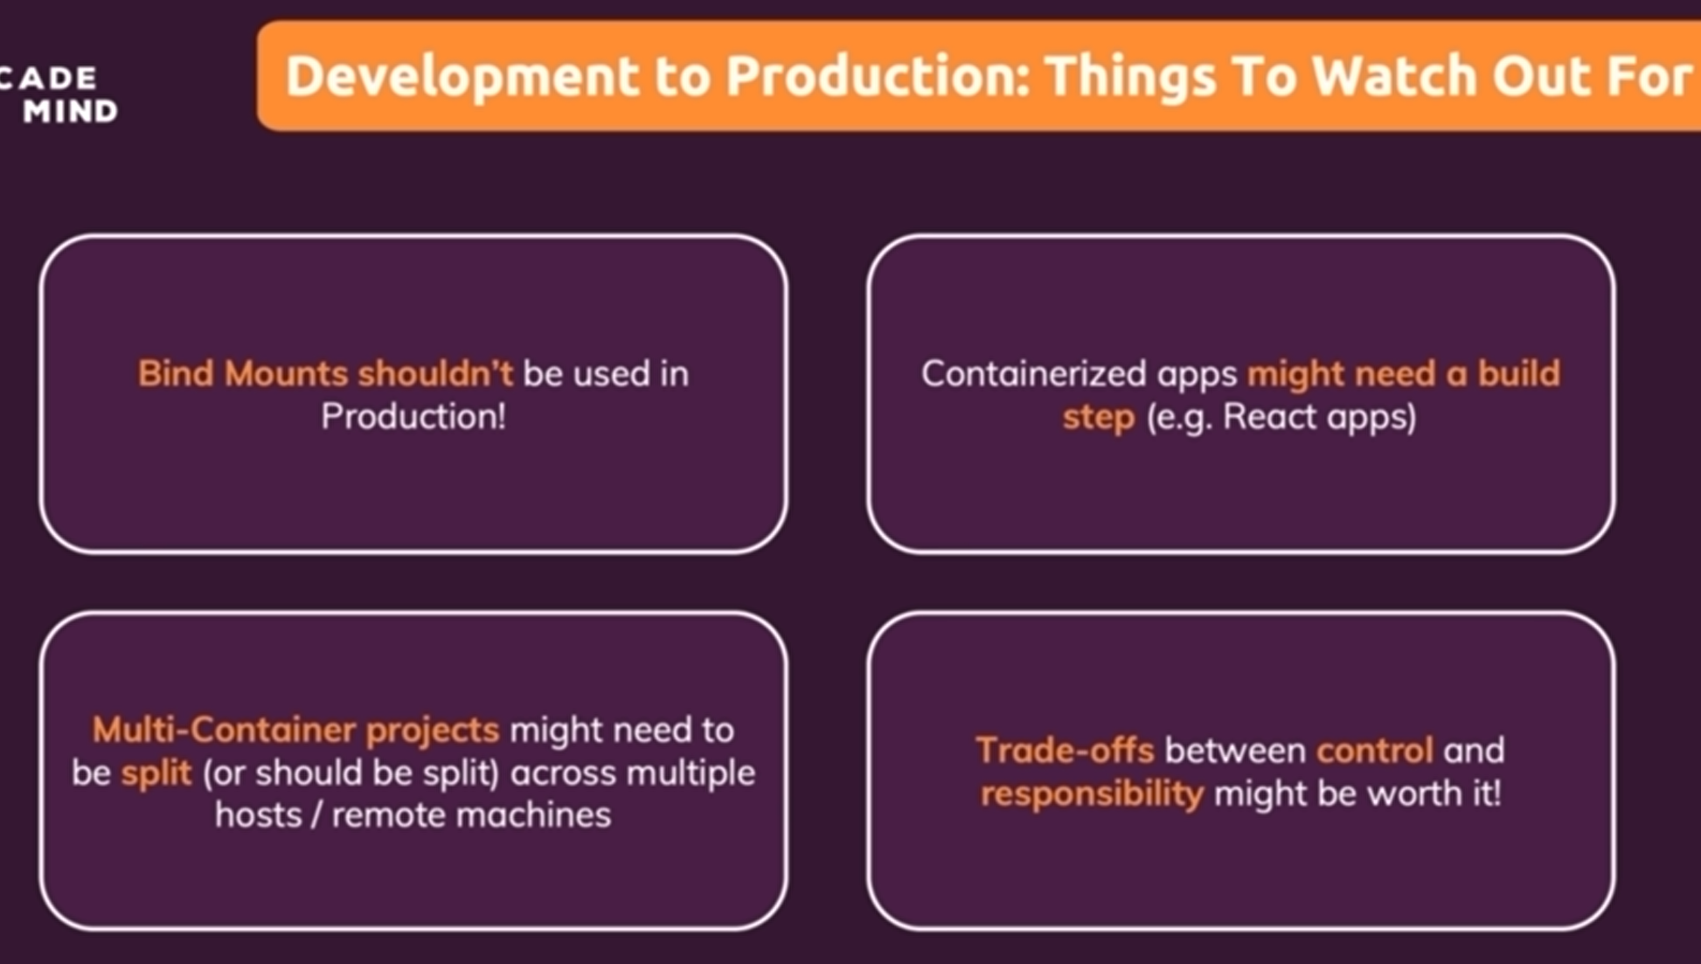

Container Deploy considerations

**Kubernetes**

Container orchestration framework to deploy containers independent of Base cloud provider.

Deploying containers manually on clouds like Amazon EC2 has many problems, like configs, security concerns,…

* containers may go down and need replace. ECS will check health of container by all and replace in need
* we might need more container instances for load balancing. ECS also do autoscaling
* Load balancing. ECS also do load balancing for our container

But ECS is constrained us on its Amazon service and we can not apply the same configs to another provider like Azure.

**Kubernetes** do all the Deployment, replace, management & monitoring, Scaling & load-balancing automatically for us.

We create **Kubernetes** configurations in that which we define container (our desired architecture) and then we send them with specific tools to custom desired cloud providers (remote machines) with **Kubernetes** machine. We can also define specific options for different cloud providers.

**Kubernetes** is like Docker-compose for multiple machines

**Pod** is a configuration file that contains a container. Workernodes runs the pod (container) and it is like virtual machine (EC2 instance). It is like a machine. It can also runs more than one Pod.

Workernodes can have more than one pod, for example if we want to make a network. The pod itself is a container and its configuration like Volumes,…. The **pod** can also have more than one container.

**Worker node**: In each worker node we could have another apps(It is like a machine), for example we should have Docker. We should also have **kubelet** which is a tool to communicate with Masternode.(a server running on the worker node).We also have **kube-proxy** that control the incoming and outgoing the traffic from/to worker node.

The pods are automatically distributed automatically by available **Worker nodes.**

**Master Node contents**:

* **APIserver** running on the machine to communicate via **kubelete**.
* **Scheduler**, watch for new Pods, selects Worker Nodes to run them on
* **Kube-Controller-Manager** watches and controls Worker nodes, correct number of Pods & more.
* **Cloud-Controller-Manager** is specific version of Kube-Controller-Manager which do the same thing but is Cloud-provider specific and knows how to interact with Cloud Provider resources.(translates them)

For big cloud providers, you might not need to manually create the Master and Worker nodes and install all the services.

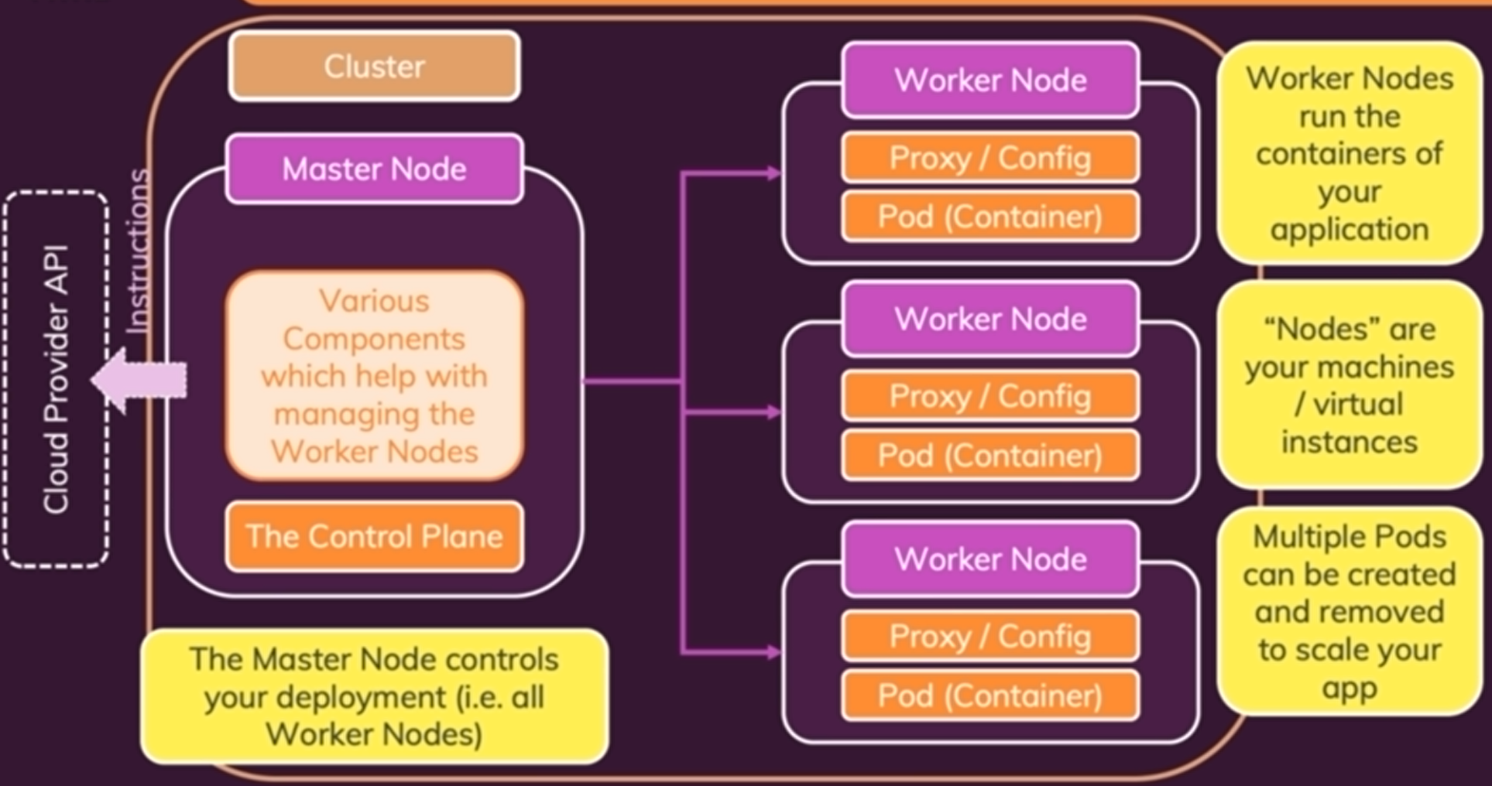

We don’t actually interact with Worker nodes but we let them managed automatically by Kubernetes and Control Plane. A Masternode is on another server and contains Control Plane

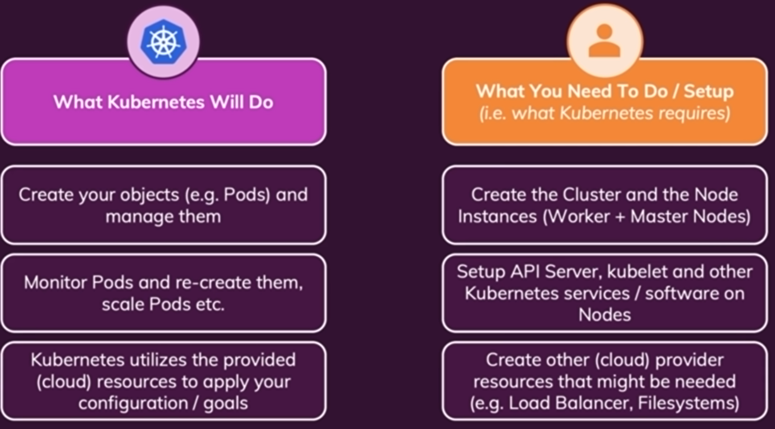

Some theoretical terms:

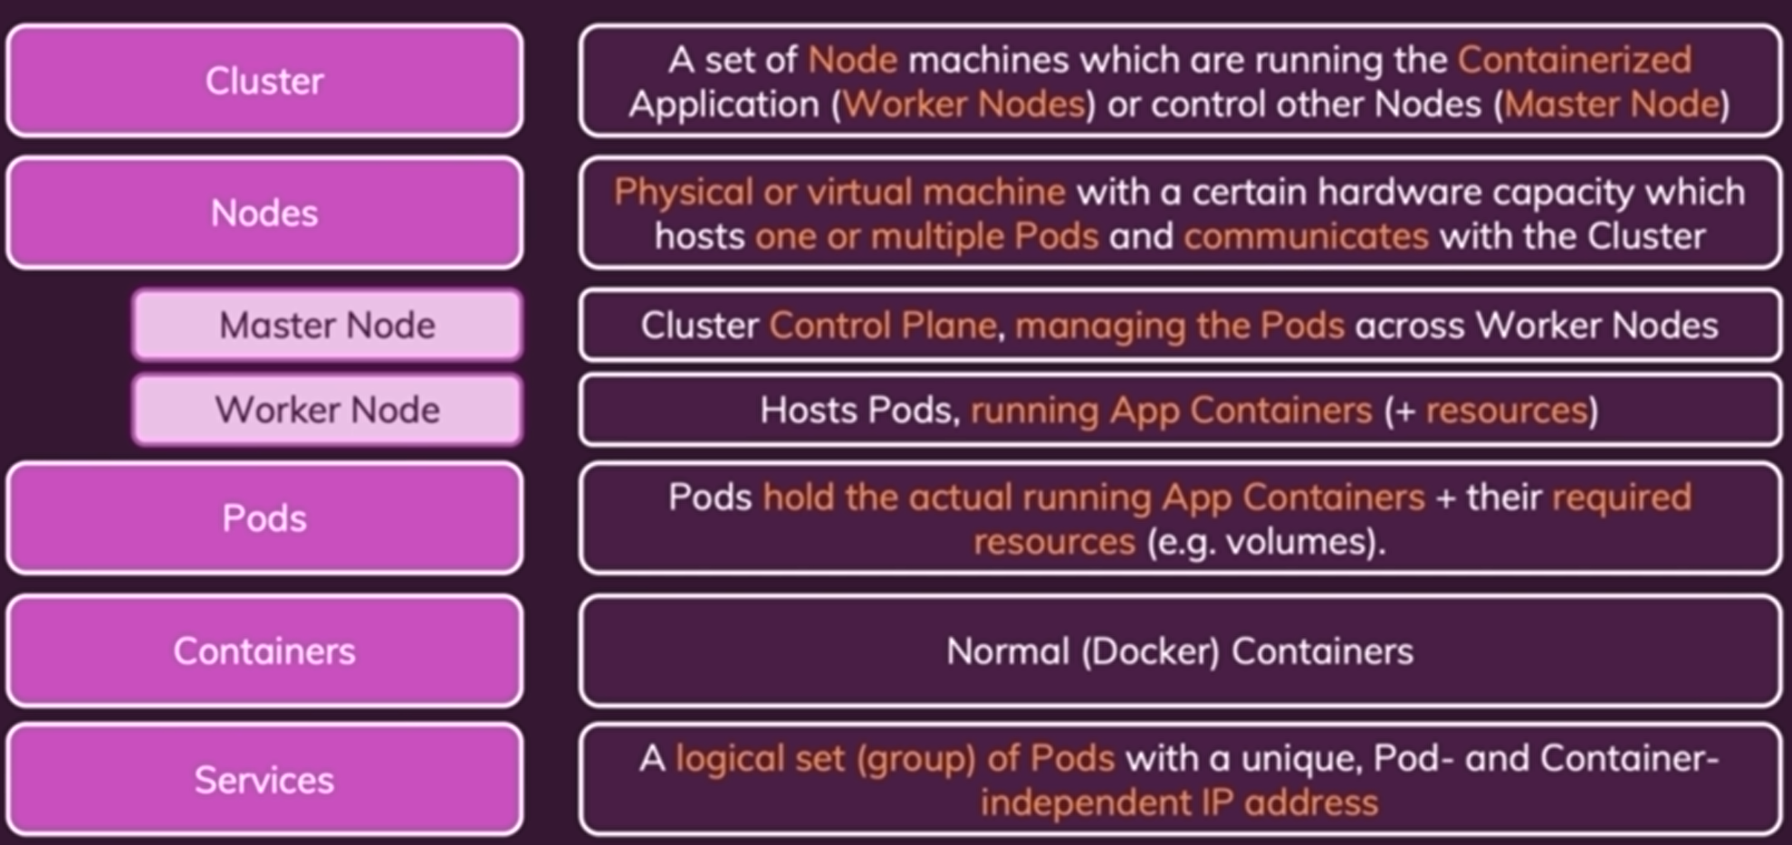

What Kubernetes do is that it actually works and manages Pods along nodes and making sure they are running. You can also manage those worker nodes and install desired services on them. But at end we also have to manage these node and ssh into them.

But tools like **Kubermatic** will also do those our tasks automatically. Also AWS and other cloud providers may have some tools that do them and we don’t have to define specific cloud provider configs (**Amazon EKS**).

**Kubectl** is a tool for sending instructions to the cluster (e.g. a new deployment) . we send them to Master node and it will apply commands and create the pods

**Minikube** is a tiny Kubernetes to run locally and it is inside a VM and we can create cluster in it. It will create worker and master node together on same machine

minikube start –driver=hyperv

minikube delete

minikube status

minikube dashboard

Kubernetes works with objects: pods, deployment, services, volume, … . We will create object by commands and Kubernetes will do all the configs and management of that for us. Kubernetes objects can be created in two ways:

* Imperatively: by running specific commands
* Declaratively: by writing and applying config files

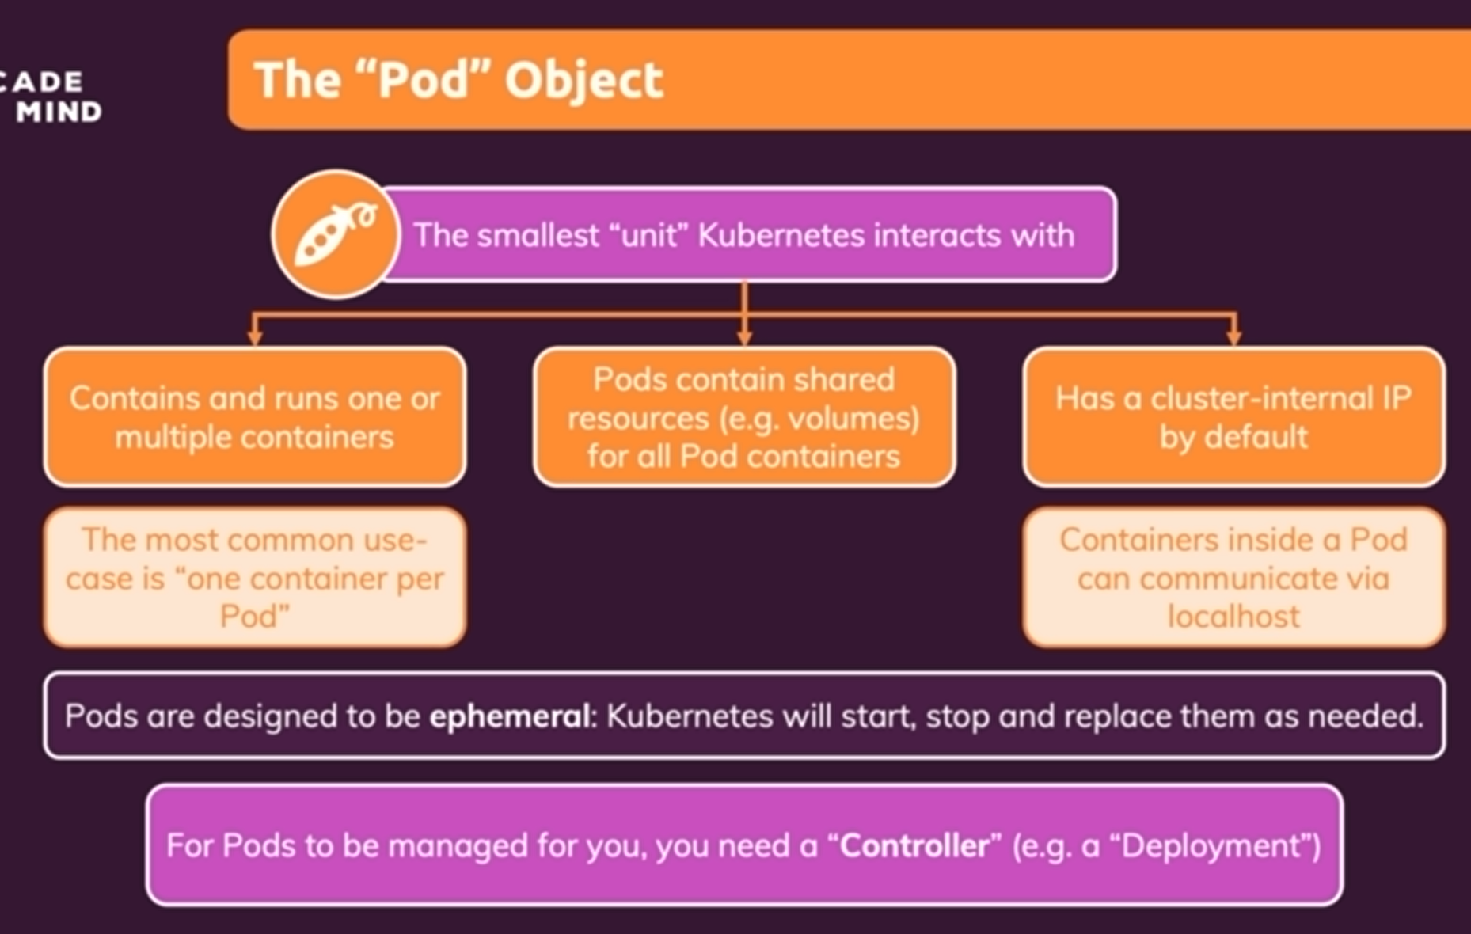

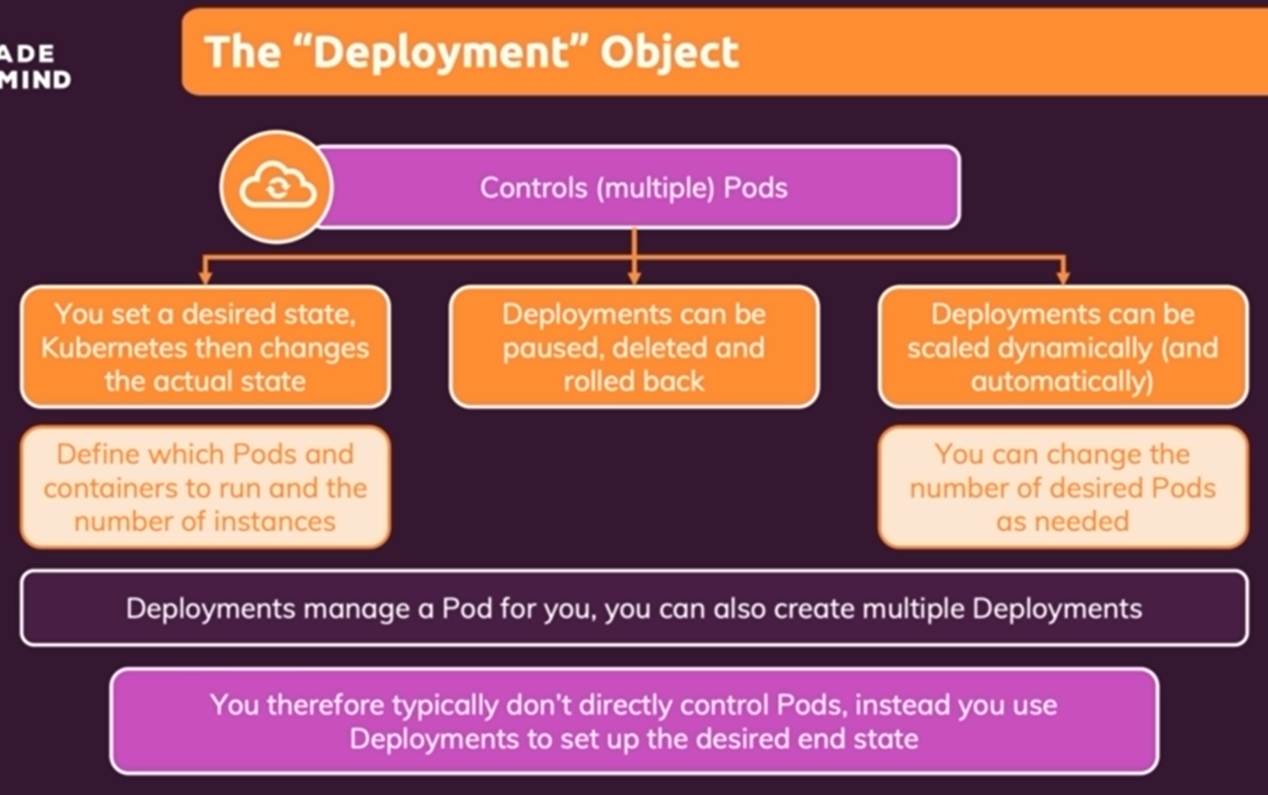

kubectl create deployment deploy_name –image=dokcerhub_url/image_name: Create a deployment to create a pod based on Image – **Imperative approach**

kubectl get deployments: get deployments in cluster

kubectl get pods

kubectl delete deployment dep_name

Pod’s IP in Kubernetes dashboard are internal IP that only accessible in cluster not our local machine.

Kubelet on the Workernodes will manage and start and monitors the pods in container

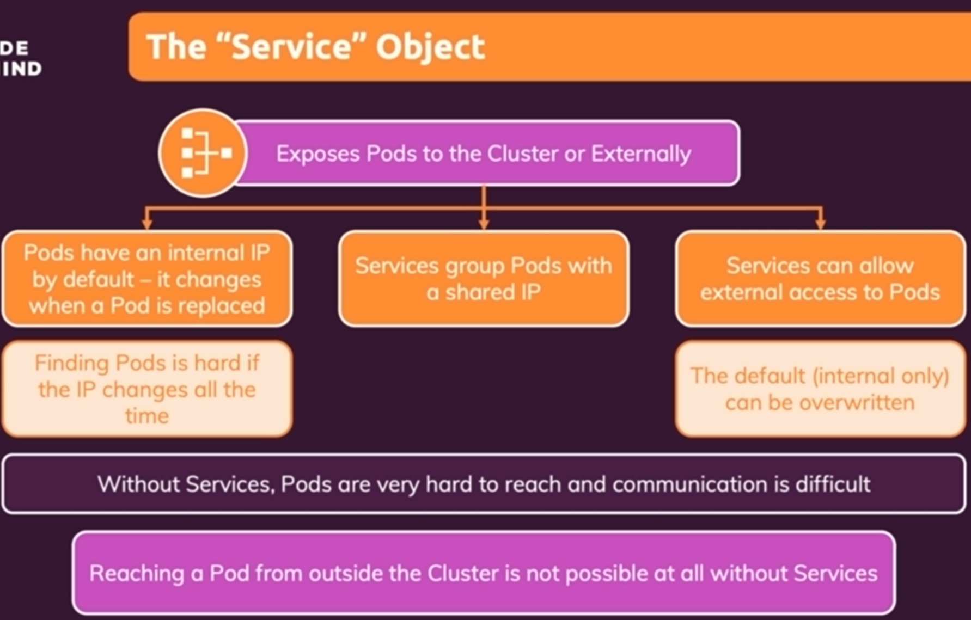

kubectl expose deployment dep_name –type=ClusterIP/NodePort/LoadBalancer –port 8080(container port that are exposing)

kubectl get services : see how to reach, if you are using minikube (local cluster), use the following command:

kubectl service dep_name

kubectl service service_name : run and see the service

kubectl scale deployment/deploy_name replicas=3

Kubectl set image deployment/deploy_name container_name=new_image_name:tag : update image of deployment. Note that the new image should have a new tag

And then to see update of container:

kubectl rollout status deployment/dep_name

kubectl rollout undo deployment/dep_name:

Roll back to latest deployment

kubectl rollout history deployment/dep_name

kubectl rollout history deployment/dep_name –revision=3

kubectl rollout undo deployment/dep_name –to-revision=3

kubectl delete service service_name

kubectl delete deployment dep_name

**Declarative approach to make deployment**:

Memorizing and repeating them all the time is a

Like docker-compose

Kubernetes allows to make resource definition files. Configuration yaml files for different objects.

kubectl apply -f=config.yaml : update cluster to a target state.

kubectl delete -f=config.yaml: delete certain resource in declarative approach. We can still delete them like imperative approach (Kubectl delete deployment …).

You can define more than one resource definition and separate them using --- . The order doesn’t matter but better to first write service and then pods,…

Selectors are related with labels in metadata.

Delete object using selectors, the resource should have label: kubectl delete [deployments,service](optional) -l label_key=label_val

